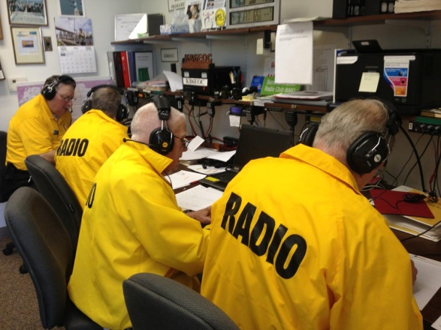  Is Ham Radio For You?  If you like being prepared for emergencies, Ham Radio is for you!  If you’d like to be a more valuable BERT team member, Ham Radio is for you!  If you like being involved in your community, Ham Radio is for you!  If you like helping people, Ham Radio is for you!  If you like technology, computers or science, Ham Radio is for you!  If you like learning new skills, Ham Radio is for you!  If you like talking to people all over the country or continent or even all over the world and beyond (like the space station), Ham Radio is for you!  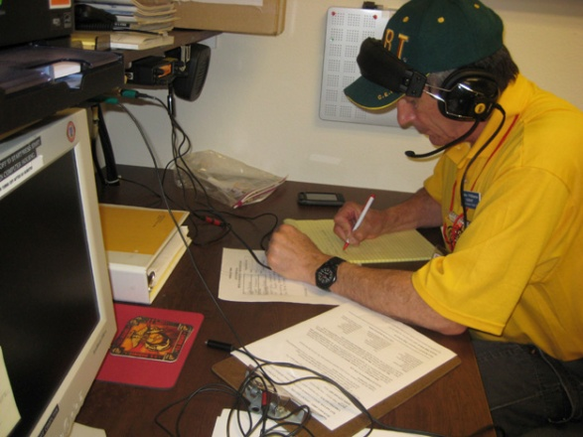 |  |  | Benicia Amateur Radio Club Invites You!  BARC is an active group of Ham Radio Operators with a slant towards Emergency Communications, working under the umbrella of the Benicia Fire Department and the Solano County Sheriff’s Office’s Auxiliary Communications Service (ACS).  The Club meets on the second Tuesday of the month in the downtown Fire Station. Doors open around 7:00 PM and the meeting starts at 7:30 PM. Most meetings also include a guest speaker.  Find Us At: https://facebook.com/BenicaARC  https://groups.yahoo.com/neo/groups/beniciaarc http://beniciaarc.wix.com/barc Twitter: Twitter.com/Benicia ARC Email: BeniciaHamRadio@gmail.com Phone: (707) 746-5858  Primary Repeater: 442.750 MHz PL-100Hz  Secondary Repeater: 441.250 MHz PL-100Hz  Benicia Amateur Radio Club  P.O. Box 1881  Benicia, CA. 94510 |  |  | Benicia Amateur Radio Club  partnering with bert  - Service to the community  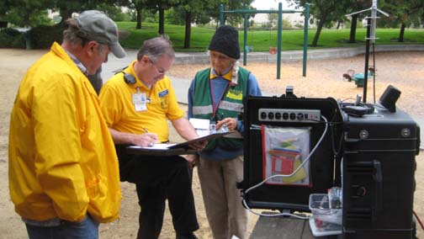  Increasing your utility in time of disaster

Disaster Strikes  BERT Responds In the aftermath of an earthquake, often landline telephones, cellphones and the internet are over-loaded or fail. You’re at your staging area and you have multiple victims. You know from your training that the Benicia Emergency Operations Center (EOC) has the ability to deploy resources to assist your team – but you are at the opposite side of the city and have no rapid way to communicate with the emergency managers. We’ve learned that the FRS radios in our caches have very limited range. What do we do?  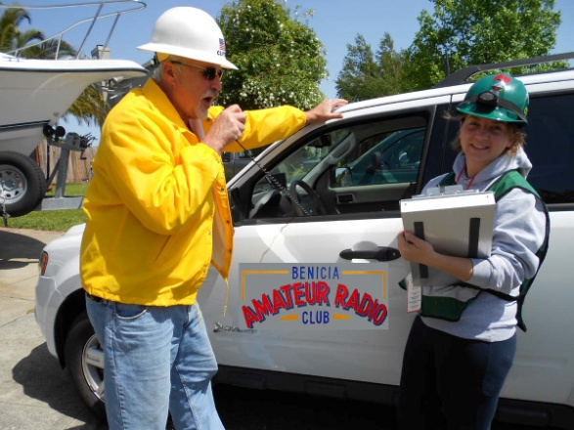  BARC Responds  Over 35 years ago Benicia’s Amateur Radio community (Hams) saw the need for alternate emergency communications in a disaster and created a team of trained radio operators. The Benicia Amateur Radio Club (BARC) was formed. Among their resources are high level, high power remote radio stations called Repeaters, that provide dependable radio coverage from all points within the city to the EOC in the downtown fire station. These repeaters have the ability to operate off the grid on their own commercial grade emergency backup power. Members of BARC individually |  |  | own and maintain their own radios and are ready to use them if called upon in an emergency.  BARC also has a cache of fully self-contained deployable radio stations on wheels that can be operated anywhere in the city limits, also off the grid.  Increasing Your Value to BERT  In 2003 a number of BERT members felt the need to expand their utility to their teams and acquired their Ham licenses. This core group is still active in both BERT and BARC and are a great asset to the City of Benicia.  Being able to respond with your team while providing an alternate means of communication to the EOC will add another dimension to your emergency response. The opportunity to get a Ham license has never been better. Please join dozens of your fellow BERT members who have gotten their licenses.  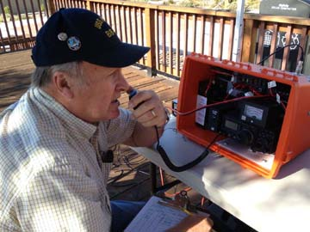  The Federal Communications Commis-sion (FCC) grants Ham licenses and requires all operators to pass a 35 ques-tion exam in order to demonstrate their understanding of radio operations, procedures and safety. |  |  | 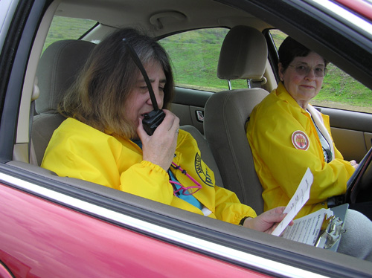  Getting Your License  Study guides and software are available at the Benicia Library or on the Internet. Ask for the Study Guide by name: “Technician Class” by Gordon West. Most people can learn what they need to know to pass the test in a week or two. And current BARC members are available to mentor beginners. Training classes are offered several times a year. Exams are held quarterly in Benicia and available monthly within a 30 minute drive. The License is free. The exam fee is $15. Radio equipment can be purchased for as little $30 on Amazon but the typical investment is around $250.  